Online System Examination Documentation
04/17/2026

Online Examination System
Authors/Team:
Authors/Team Members | ID
Ahmed Medhat | 250103835
Amna Ezzat Abdelsalam | 250100812
Sana Muhammed | 250102054
Jana Gamal | 250102122

Github Repo:

Project Overview
Online Examination System is a full-stack web application designed to digitize the exam creation, execution, and evaluation process for educational institutions. It enables instructors to create timed exams with multiple-choice and short-answer questions, while students can take exams remotely and receive instant results.

Project Objectives:
The main objectives of this project are:
- Design a well-structured relational database schema.
- Ensure data integrity using primary keys and foreign key constraints.
- Support multiple roles: students and instructors.
- Store and manage exam questions and answers efficiently. Automatically evaluate student responses and calculate scores. Develop a full-stack system integrated with the database.
- Provide scalability for future enhancements.

Entity Relationship Diagram (ERD)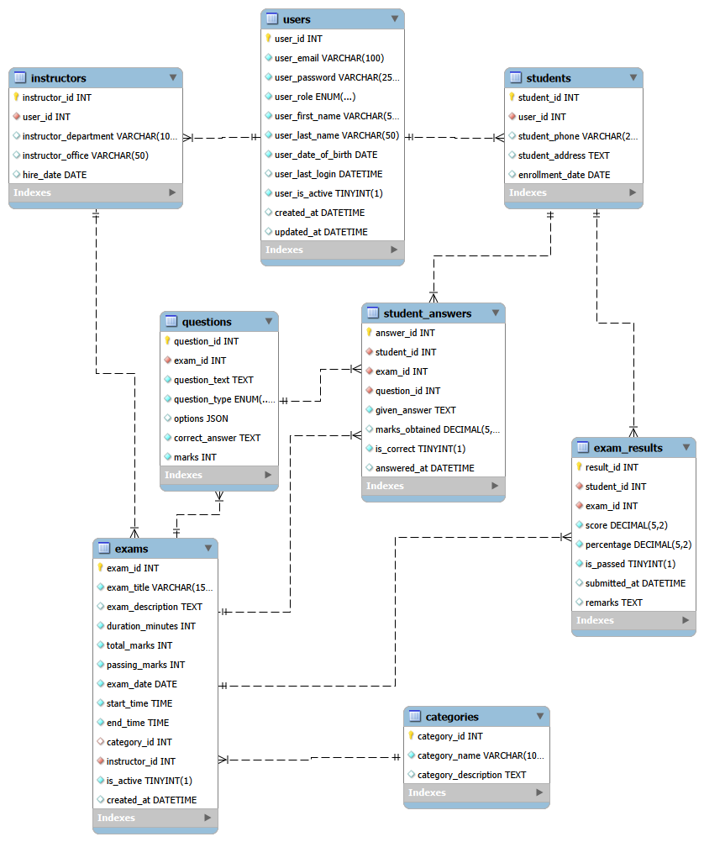

System Overview:
The system consists of two main components:
Database Layer:
- Built using MySQL.
- Handles data storage, relationships, and constraints.
Application Layer:
- Frontend: React (JavaScript + Vite)
- Backend: Node.js (Express.js) Enables interaction between users and the database.

Conclusion:
This project successfully demonstrates the design and implementation of a database system for an online examination platform. The system ensures efficient data management, supports multiple users, and provides accurate exam evaluation.
Future improvements may include:
- Adding authentication & security enhancements
- Supporting real-time exams
- Improving UI/UX design
- Adding analytics and reporting features

License
This project is developed for educational purposes.
All rights reserved by the development team.

